**How to upgrade firmware from 2.0.0.8 to 2.0.0.23 on ECS5510-48S**

**Topology:**

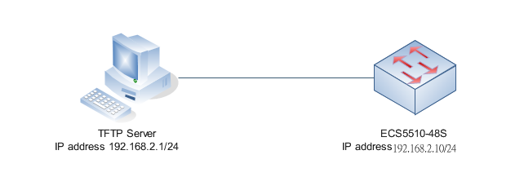

**Version:**

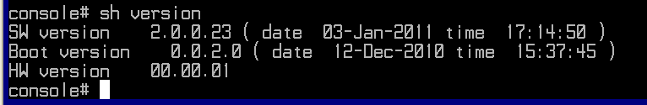

1. Set switch IP address.

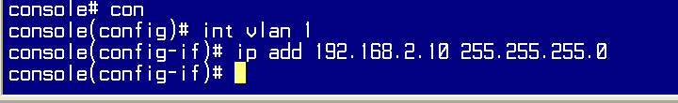

1. Ping 192.168.2.1/24(TFTP server).

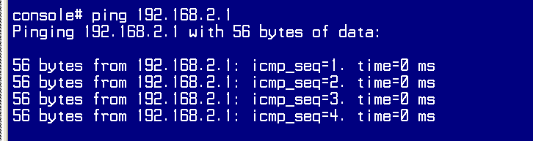

1. Copy firmware (lion_edg-20032.ros) from TFTP server to switch.

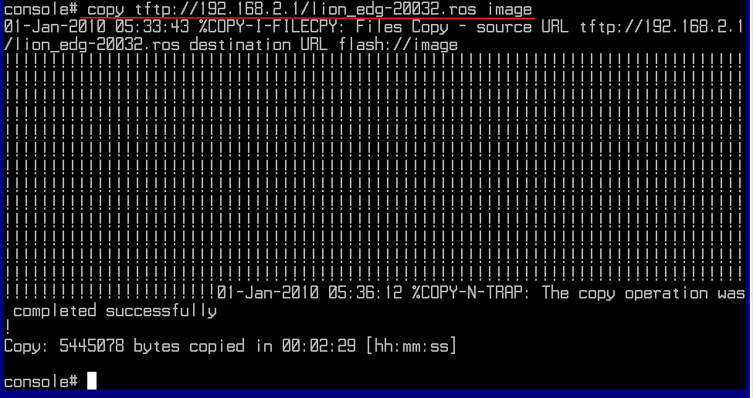

1. Reload the switch and then check the version.

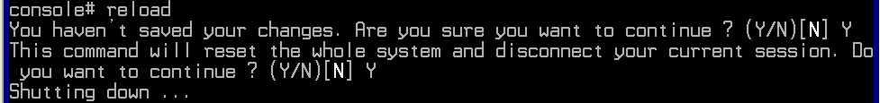

1. Finish

