How to upgrade firmware from 2.0.0.8 to 2.0.0.23 on ECS5510-48S

Topology:
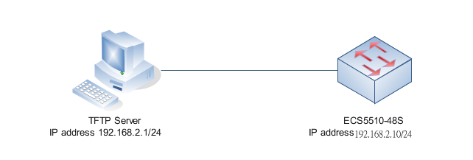
Version:


- Set switch IP address.
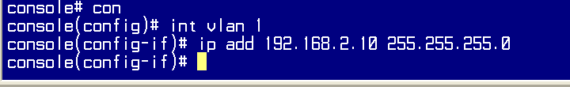

- Ping 192.168.2.1/24(TFTP server).
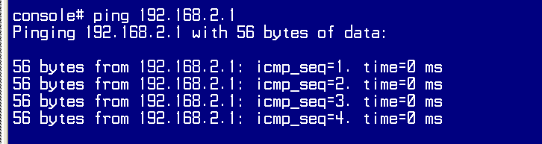

- Copy firmware (image) from TFTP server to switch.
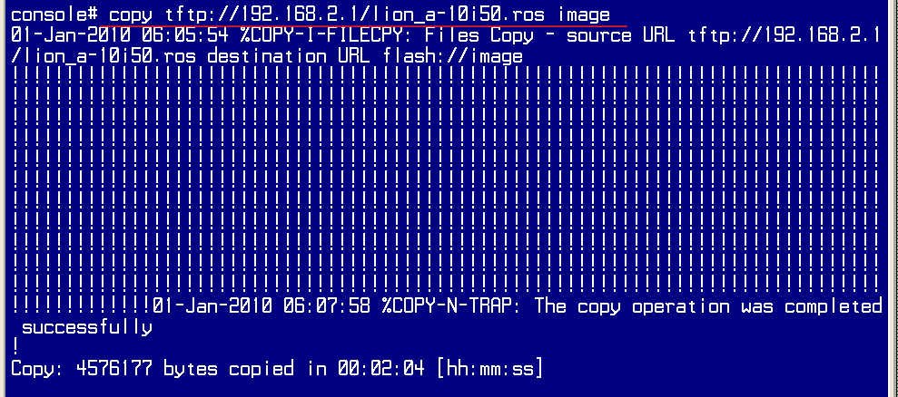

- “Show boorvar” to check the image for the next boot. If not 1.0.i.50, please use “boot”
If not, use command “boot system image-x” to change the firmware(image).
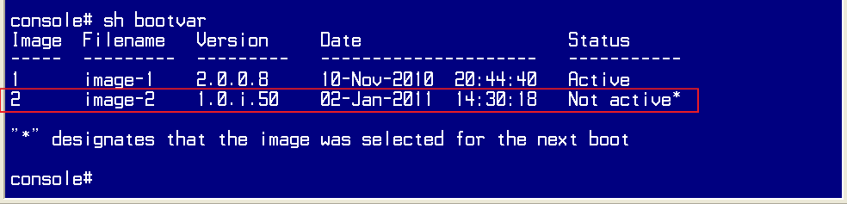
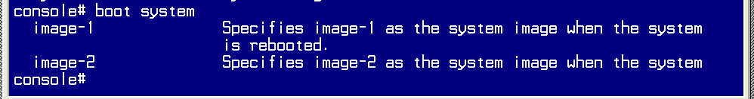

- Reload
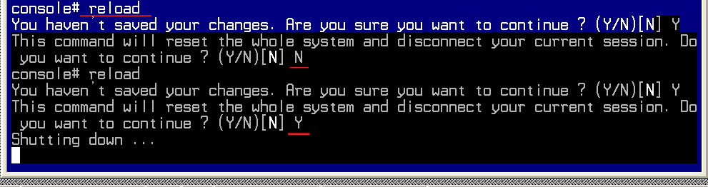

- Set ip address and ping the TFTP server

- Upgrade the firmware to 2.0.0.23
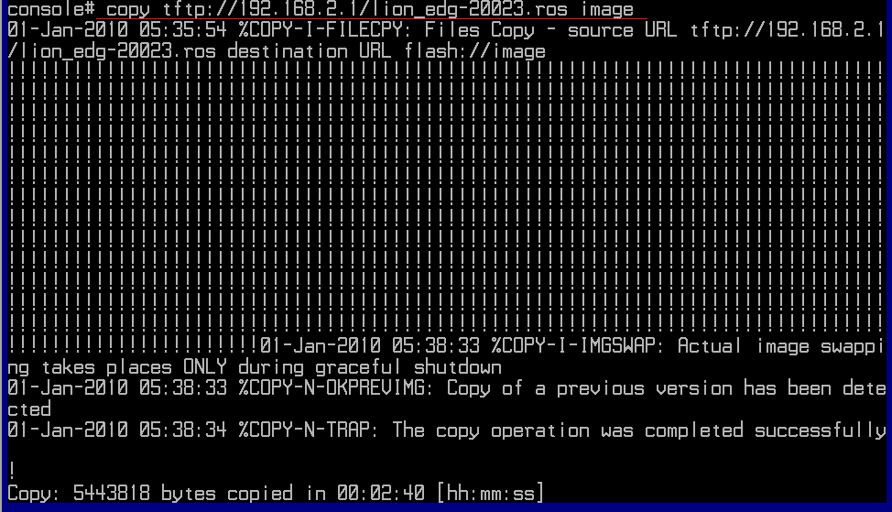

- Upgrade the boot(edgecore_lion_accton_boot-0020.rfb) to 0.0.2.0
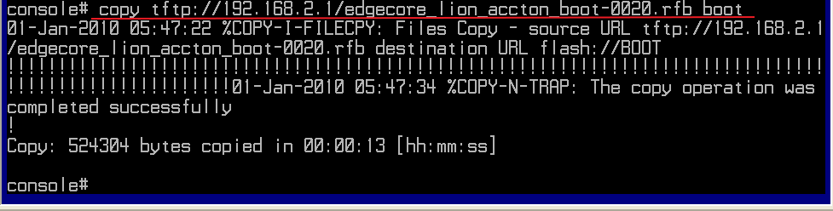

- Reload the switch and the “show version” to check the upgrade firmware version.


